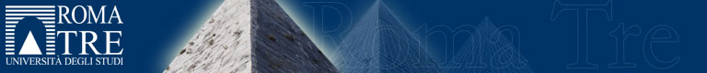
Short Course
Earth Science PhD School “Roma Tre University”

Thermometry, chronometry, barometry and fluid geochemistry in sedimentary basins

Dr. Marta Gasparrini
GeoRessources Departement, IFP Energies nouvelles
Rueil-Malmaison, France

17-21 September 2018
Dipartimento di Scienze, Università “Roma Tre”
Where: Blocco Aule - Largo San Leonardo Murialdo, 1 - Roma

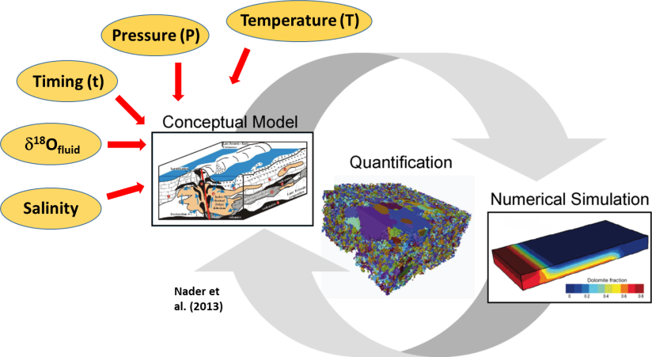
September 17th
Morning session: Carbonate diagenesis: why we care
Afternoon session: Tools for integrated studies: Fluid Thermometry & geochemistry
September 18th
Morning session: Tools for integrated studies: Relative / absolute chronometry
Afternoon session: Applications to basin / reservoir scales
September 19th
Morning and afternoon sessions: Applications to basin / reservoir scales
September 20th
Morning and afternoon sessions: Fluid Barometry and application
Afternoon session: Future Perspectives
September 21st
Morning session: Open session with PhD students

Question time and short breaks will be managed by the speaker during lecture time. For further infos and registration contact sveva.corrado@uniroma3.it

