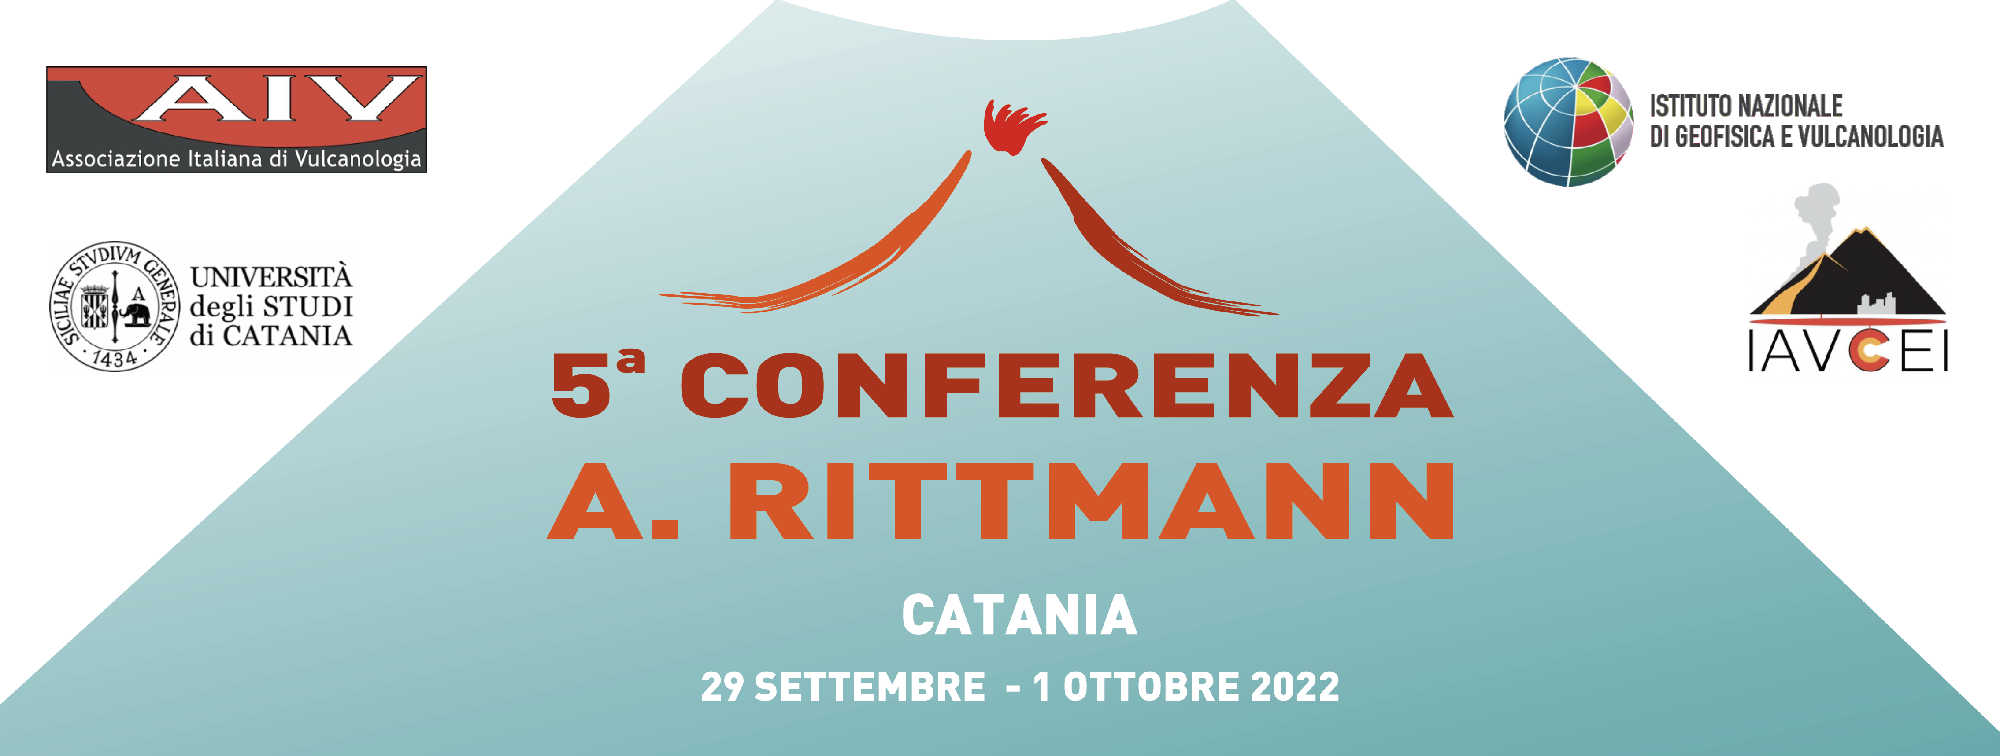

SESSION PROPOSAL

Send before March 12, 2022 to the e-mail address: segreteria@conferenzarittmann.it

Session Title (in English, max 150 char. including spaces)

Applicants (min 2, max 4; please indicate only 1 applicant as corresponding)
1. Name and Surname*, Affiliation, e-mail address (*corresponding)
2. Name and Surname, Affiliation, e-mail address
3. Name and Surname, Affiliation, e-mail address
4. Name and Surname, Affiliation, e-mail address

Description (in English, max 200 words)

